The Jazz Loft
275 Christian Avenue Stony Brook
NY 11790 631-751-1895
For immediate release
May 24, 2023

The Jazz Loft’s ‘Young at Heart’ Series Highlights Latin Jazz with ‘Broadway Jazz’

Stony Brook, NY-The Jazz Loft, 275 Christian Avenue in Stony Brook, will be presenting the popular Young at Heart daytime concert series on June 7 when the Loft highlights Broadway Jazz.
The Young at Heart series is a monthly themed series that takes place in the afternoon, making it easier for seniors to attend a concert during the day. The Young at Heart series also serves as a wonderful opportunity for those with memory loss to remember and enjoy familiar tunes.
The band will feature Jazz Loft founder Thomas Manuel and the Young at Heart Trio, with Manuel on cornet; Steve Salerno on guitar; and Keenan Zach on bass. All concerts are from 1-2 p.m. for the discounted price of just $10. Tickets can be purchased here: https://www.thejazzloft.org/tickets
“I often hear from seniors that it may be difficult for them to travel out at night and so I created the ‘Young at Heart Series ‘which takes place in the afternoon,” said Jazz Loft founder Thomas Manuel. “The one-hour programs are designed to be interactive and embrace story telling. Each theme is a trip down memory lane and a great way for folks to reminisce about different artists and time periods. The Young at Heart series also strives to help seniors or anyone with memory loss with the help of music.”
The Jazz Loft is located just 90 minutes from New York City and is the only music venue on Long Island that features exclusively Jazz music. For more information about The Jazz Loft, visit our website.
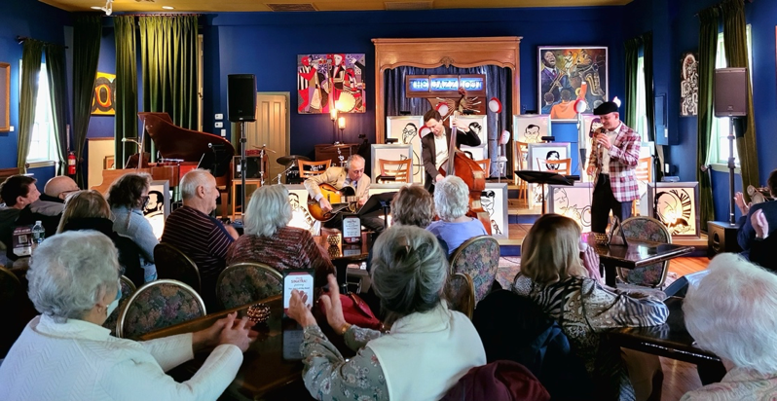
Caption: The Young at Heart concert series will feature pieces of Latin Jazz

