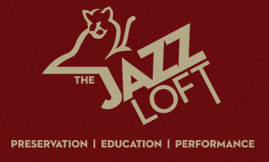

The Jazz Loft
275 Christian Avenue
Stony Brook, NY 11790
631-751-1895
For immediate release
May 24, 2023

The Jazz Loft Presents a Havana Night in the Basie Garden with Mambo Loco

Stony Brook, NY-If a warm summer evening listening to the distinct sounds of classic Afro-Cuban music sounds like your thing, then you will not want to miss the Jazz Loft’s Havana Night in the Basie Garden on Saturday, June 17 at 7 p.m. featuring Mambo Loco, a seven-piece Long Island-based band that brings audiences the best of classic Afro-Cuban music.

The event will include a complimentary Cuban cocktail, wine or beer, a hand-rolled cigar, and passed hors d’oeuvres.

“This event will be an immersive experience into Cuban jazz and culture,” said Jazz Loft Founder Tom Manuel. “I’m thrilled to bring the sound of Mambo Loco to the Jazz Loft.”

Tickets are $75 and can be purchased here: The Jazz Loft.

More about the band
Formed in 2001, Mambo Loco has become synonymous with the classic music of Afro-Cuban and Puerto Rican origin. Lead vocal and percussionist Larry Belford has been performing since he was a child growing up on New York's Long Island. As an adult he has performed in or with many of the best Latin groups in NY including the Bad Street Boys, Charlie Rodriguez, Johnny Pacheco, Roberto Torres and Celia Cruz. His fiery playing and vocals are the focal point of the band. A founding member and highly regarded in the top NYC Latin circuit, conguero, percussionist and vocalist Cristian Rivera has over the past years performed and toured with Frankie Morales, Tito Puente, Nestor Torres and Willie Colon just to name a few. Bill Smith, piano and vocals, brings to each performance a varied palate of musical styles. After obtaining his degree at Berklee College of Music, he has over the years been a member or performed with the Skatilites, Monty Alexander, Dr. John and Bakithi Kumalo. Wayne Burgess, bass & vocals, also a Berklee alumnus, anchors the group with many years of live performance experience, arranging and record production. From coast to coast he has performed with Orquesta Opa Opa , Johnny Martinez Orquesta, The Drifters, The Coasters and Billy Ekstine. We'd also like to add thanks to current trumpeter Steve Gluzband of Ray Barretto fame, saxophone and flautist Mike Sagarese and trombonist Jose Rivera for contributing so much to the sound of the group.

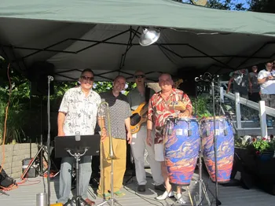
Caption: Mambo Loco

