The Jazz Loft
275 Christian Avenue
Stony Brook, NY 11790
https://www.thejazzloft.org.
631-751-1895
May 24, 2023

For immediate release

The Jazz Loft Presents Three Performances of
Duke Ellington’s Grammy-Award Winning
Far East Suite

Stony Brook, NY- The Jazz Loft in Stony Brook will present three special performances of
Duke Ellington’s Far East Suite on Thursday, June 2 and Friday, June 3. The Far East Suite is a 1967 concept album by Ellington, inspired by his group's 1963 tour of Asia. Ellington and longtime collaborator Billy Strayhorn wrote the compositions. The album won the Grammy Award in 1968. The concert are sponsored in part by the Olivia and Harlan Fischer Concert series and a grant from New York State Council on the Arts.

“Here at the Jazz Loft, we are always striving to bring our audience unique and significant works of Jazz and to keep those works alive and well,” said Tom Manuel, founder of the Jazz Loft. “Duke Ellington’s Far East Suite is the result of an ambitious tour that the band undertook back in the 60’s. I am excited to be sharing this work nearly 60 years after it won a Grammy award.”

Both performances of the Far East Suite will be at 7 p.m. Tickets can be purchased: Tickets.
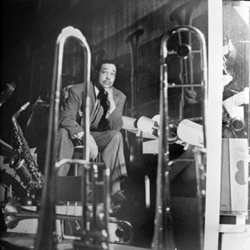

Duke Ellington
Courtesy The Jazz Loft, Burt Goldblatt Archives

