The Jazz Loft
275 Christian Avenue
Stony Brook, NY 11790
631-751-1895
For immediate release
May 24, 2023

The Jazz Loft, SBU & SB Medicine Present ‘Summer SWAP Series’ a Unique Outdoor Space Experience
Offering four Thursday evenings of music on the lawn

Stony Brook, NY- The Jazz Loft in Stony Brook, in partnership with Stony Brook University, Stony Brook Medicine and community businesses will be presenting the 2023 Summer Stage With A Purpose (Summer SWAP), on a series of Thursday evening throughout the summer. The events are FREE to the community.

Summer SWAP will offer visitors a relaxing and scenic outdoor venue on the front lawn of the Jazz Loft to listen to an impressive lineup of performers.

“This series was born from the desire to have the Jazz Loft collaborate with Stony Brook University, and Stony Book Medicine as a way to invest in the community and especially to nurture cultural development,” said Jazz Loft founder Tom Manuel.

"We are so proud that Thomas Manuel, a member of our university community, has established the Jazz Loft, which celebrates the history and performance of jazz," said Judith Greiman, Chief Deputy to the President/Senior Vice President for Government and Community Relations. "We welcomed the opportunity to sponsor these shows, enabling our broader community to come together to enjoy extraordinary musical talent."

The Jazz Loft will be offering a variety of refreshments for sale in the Basie Garden which is adjacent to the Jazz Loft. Attendees are welcome to bring their own chairs and blankets to set up on the lawn.
The series performers will include:
June 8: The Phoenix Big Band
June 22: The Equity Brass Band-featuring Ray Anderson, sousaphone; Rod Borrie, trombone; Ellis Holmes III, drums; Vinny Raniolo, banjo; Eric Kay, clarinet; and Tom Manuel, cornet
July 13: Nikos Chatzitsakos Tiny Big Band featuring vocalist Alexandria DeWalt
August 10: Melanie Marod Ensemble
All performances are from 6 to 8 p.m.

For more information contact the Jazz Loft at: 631-751-1895 or visit https://www.thejazzloft.org

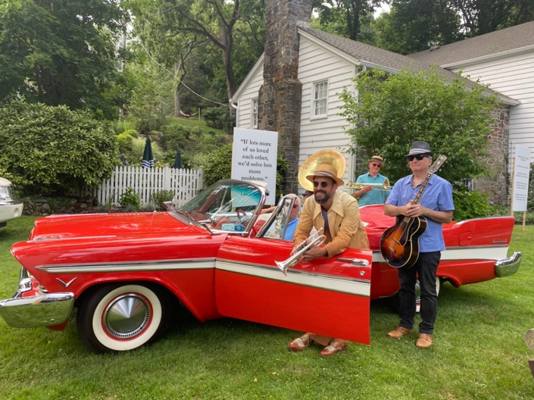
Photo courtesy of the Jazz Loft
Caption: The Equity Brass Band will perform on June 22 on the front lawn of the Jazz Loft.

