The Jazz Loft
275 Christian Avenue
Stony Brook, NY 11790
631-751-1895
For immediate release

June 23, 20222
Coming in Hot!
Reoccurring Events to Look Out for This Summer July – August

Stony Brook, NY- The Jazz Loft has a variety of performance series that happens every month. Look out for these upcoming performances at The Jazz Loft.

Wednesday, July 5, at 1 p.m.
Young at Heart Series: We Take Requests
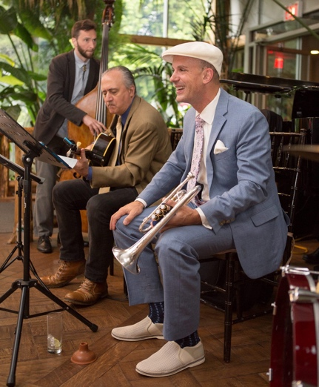
The Young at Heart series occurs every first Wednesday of the month, each having a different theme. This band consists of the Jazz Loft founder Thomas Manuel on cornet, Steve Salerno on guitar, and Keenan Zach on bass.

All concerts are from 1-2 p.m. for the discounted price of just $10. Tickets can be purchased here: Tickets
Every Wednesday, at 7 p.m.
Jam Sessions
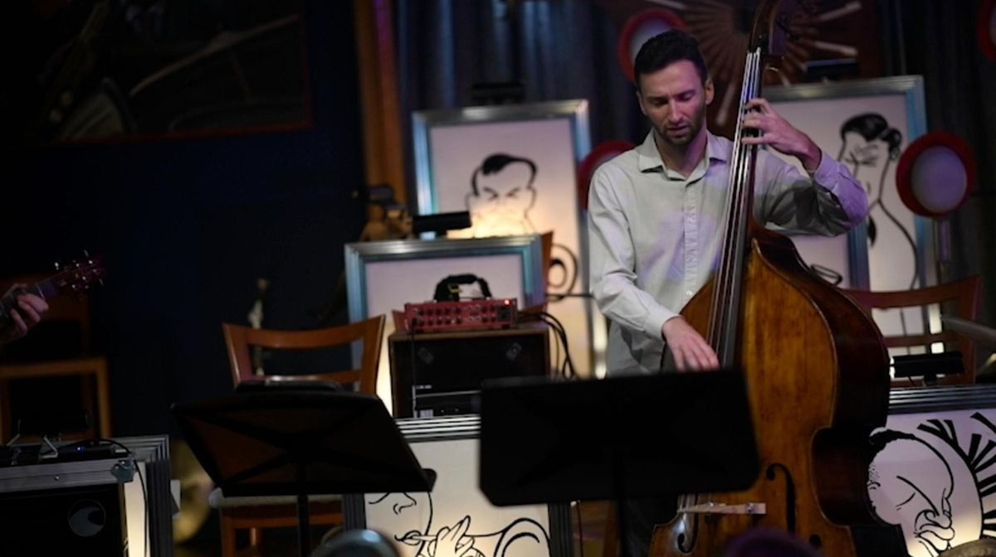
(Image source: Newsday)
Jam sessions happen every Wednesday from 7 p.m. - 9 p.m. The Keenan Zach Trio performs for the first hour and leads into an open jam session for the rest of the night.

All Jam session tickets cost $10 and $5 after 8 p.m. Tickets can be purchased here: Tickets

Thursday, July 6 and 7, at 7 p.m.
Big Band: Viva Cuba!
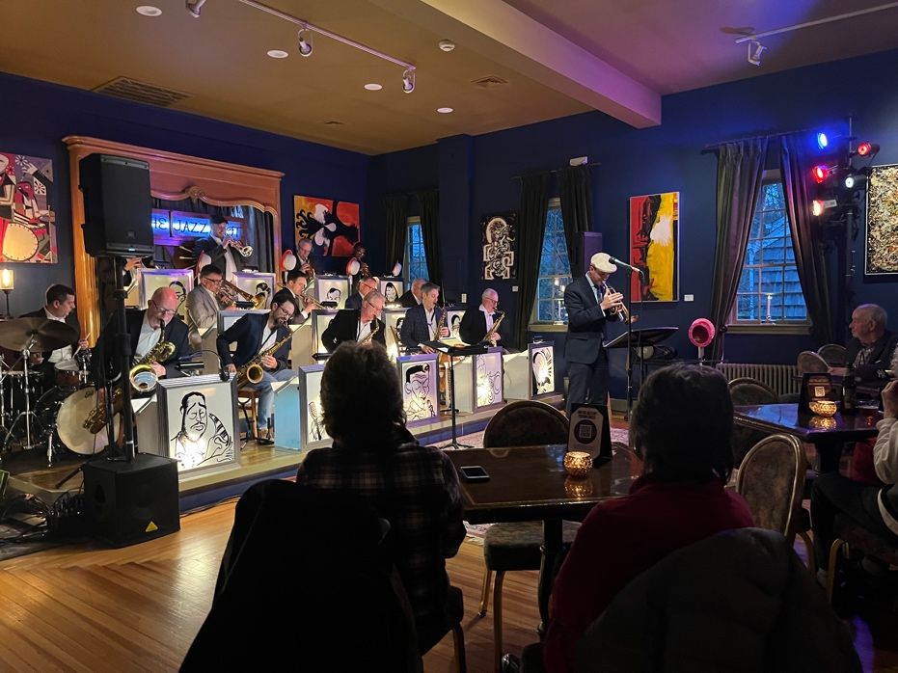
Big Band performs every first Thursday of the month from 7 p.m. - 9:30 p.m. In the month July, Big Band will perform a unique project, Viva Cuba!, celebrating the music of Prez Prado, Xavier Cugat, Machito, Tito Puente and others. The performance will be held on Thursday, July 6, and July 7 at 7 p.m.

Big Band: Viva Cuba! tickets cost (adults) $40, (seniors 62+) $35, (students) $30, (children) $25 Tickets can be purchased here: Tickets

Thursday, July 20, at 7 p.m.
The Bad Little Big Band
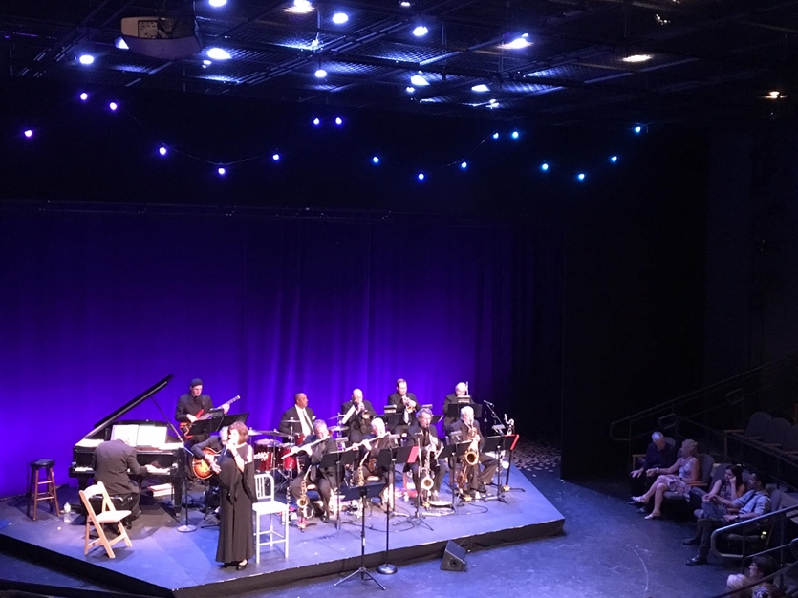
The Bad Little Big Band performs every third Thursday. This band has been together for over 40 years, with director Rich Iacona (Pianist) creating all the arrangements and compositions. What makes this band special is their inclusion of vocals, featuring Madeline Cole.

All performances are from 7 p.m. - 9:30 p.m. for the price of (adults) $30, (seniors 62+) $25, (students) $20, (children) $15. Tickets can be purchased here: Tickets

Thursday, July 27, at 7 p.m.
Interplay Jazz Orchestra
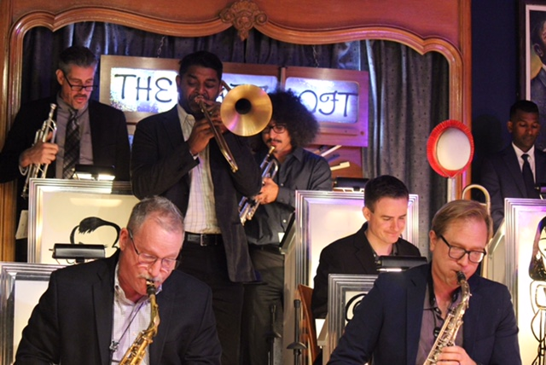
Interplay Jazz Orchestra happens every fourth Thursday of the month. Interplay is a newer band composed of younger performers and music educators from Long Island. This 16-piece co-lead band all contribute to creating their arrangements and compositions.

Every concert is from 7 p.m. - 9:30 p.m. for the price of (adults) $30, (seniors 62+) $25, (students) $20, (children) $15. Tickets can be purchased here: Tickets
Wednesday, July 2, at 1 p.m.
Young at Heart Series: Boddy Darin
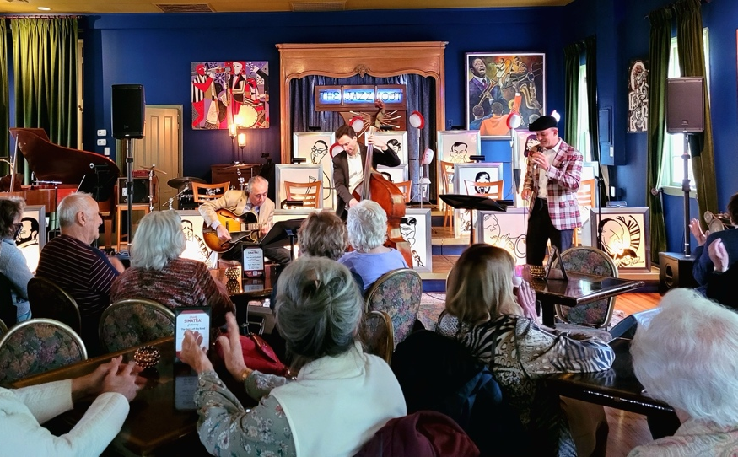
The Young at Heart series occurs every first Wednesday of the month, each having a different theme. This band consists of the Jazz Loft founder Thomas Manuel on cornet, Steve Salerno on guitar, and Keenan Zach on bass.

All concerts are from 1-2 p.m. for the discounted price of just $10. Tickets can be purchased here: Tickets

Thursday, August 3, at 7 p.m.
Big Band: Stomping at the Savory!
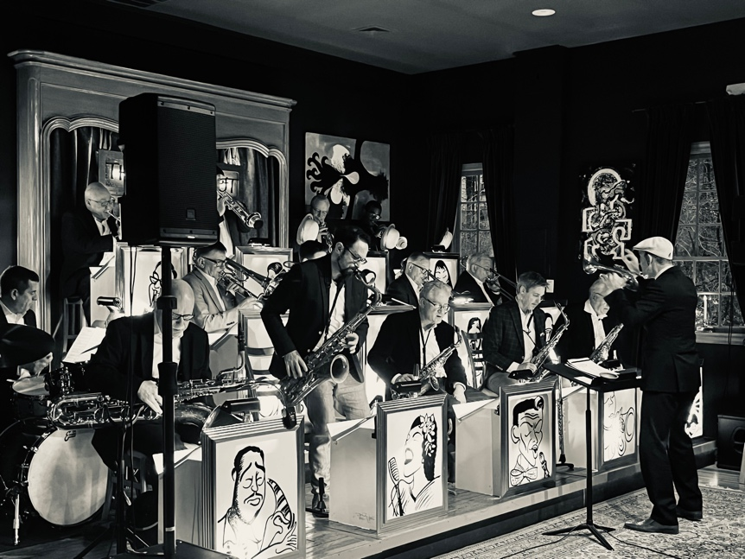
Big Band performs every first Thursday of the month from 7 p.m. - 9:30 p.m. In August, Big Band: Stomping at the Savory will celebrate the Lindy Hop Swing craze of the 1940s.
Most Big Band concert tickets cost (adults) $30, (seniors 62+) $25, (students) $20, (children) $15. Tickets can be purchased here: Tickets

